**Adding a collaborator to a GitHub Repository**

1. If you are using GitHub Free, you can add unlimited collaborators on public and private repositories.
2. Repositories owned by an organization can grant more granular access.
3. Pending invitations will expire after 7 days, restoring any unclaimed licenses.

**Note:** GitHub limits the number of people who can be invited to a repository within a 24-hour period. If you exceed this limit, either wait 24 hours or create an organization to collaborate with more people.

1. Ask for the username of the person you're inviting as a collaborator.
2. On GitHub, navigate to the main page of the repository.
3. Under your repository name, click Settings.

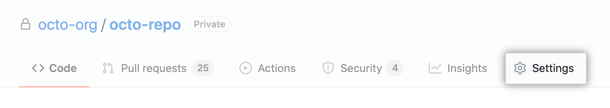

1. In the left sidebar, click **Manage access**.



1. Click **Invite a collaborator**.



1. In the search field, start typing the name of person you want to invite, then click a name in the list of matches.

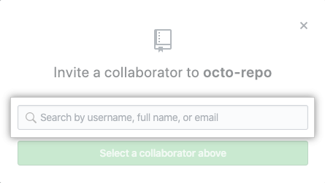

1. Click **Add NAME to REPOSITORY**.

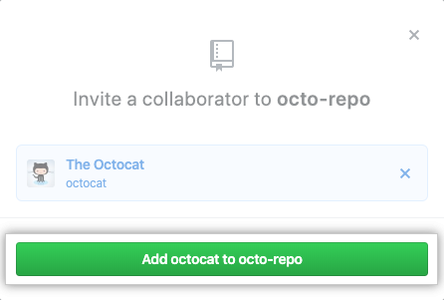

1. The user will receive an email inviting them to the repository. Once they accept your invitation, they will have collaborator access to your repository.